You did What with my Retirement?
Moral Hazard,
The Pension Benefit Guarantee Corporation and Pension Plans

Scott Brozena Senior Thesis
Professor Warning
May 12th, 2006
Table of Contents
- Abstract
- Introduction
  - Figure 1: Concentration of PBGC claims
- Background
  - Defined Contribution Plans
  - Defined Benefit Plans
  - Pension Benefit Guaranty Corporation
  - Table 1: Employee and Employer Advantages and Disadvantages of Defined Benefit and Defined Contribution Plans
- Current State of Under-Funded Pension Plans
- Termination of Defined Benefit Plans
  - Standard Termination
  - Distress Termination
  - United Airlines Distress Termination
  - Table 2: Maximum Monthly PBGC Payout
- Freezing Pension Plans
  - How It Works?
  - Verizon Example
- Moral Hazard Problem
6.1 Incentives to Under Fund Defined Benefit Plans
  - Figure 2: PBGC Benefit Payments
  - Bradley Belt Testimony
  - Akerloff’s Market for Lemons Example
- Competitive Advantages Gained by Companies Who Abandon Plans
  - United Victory
  - Figure 3: PBGC Claims by Industry
- How Companies Get Away with Cutting Pension Plans
  - Hidden Information Problem
  - Under Funding plans
- What Can be Done?
  - PBGC Deficit
  - Figure 4: PBGC Deficit and Surplus Fluctuations
  - Bush Administration Bill
- Alternatives (DC Plans: 401(k))
  - Shift to DC Plans
- Pension Wars to Come
  - New York City Transit Strike
- Conclusion
- References

Abstract
There is a changing landscape in employer sponsored pensions where defined benefit plans are being phased out of the workplace in favor of less risky and less costly defined contribution plans. As companies move away from the once considered “secure” defined contribution plans, employee’s financial futures are being jeopardized. This paper seeks to examine the reasons why freezing or terminating defined contribution plans is a new trend for large companies and the implications this will have on retirement security. This trend is further influenced by the moral hazard problem created by the government backed Pension Benefit Guaranty Corporation as companies realize the safety netting created by this insurance agency.

Introduction

United Airlines employees work long hours arriving at the airport at 5am as they leave their families for 3 to 4 days at a time with the assurance that one day they will retire with a full pension plan. However, these 120,000 current employees have recently had to put their retirement dreams on hold as their pension plans might now be in jeopardy. After a Chicago bankruptcy judge allowed United to transfer their pension plan financial responsibilities over to the Pension Benefit Guaranty Corporation (PBGC) in May of 2005, employees are uncertain of their financial future.
Pension plans have provided a great deal of uncertainty in recent years as large companies such as United and IBM have been able to legally freeze or even terminate employee plans. Many large companies now have significantly under funded pension plans due to skyrocketing pension costs from recent market uncertainty, an aging workforce, and rising short-term interest rates. IBM is anticipating a jump of $900 million in pension expenses from 2005 to 2006 crediting the majority of the increase to rising short-term rates. “In this cash balance plan, the rate at which IBM credits interest to their accounts moves with the short-term rates (Byrnes, 2006).” That rate has changed significantly in the past year from 3.1% to 5%, accounting for $200 million in additional costs.
This recent trend by large companies to freeze or terminate their pension plans has employees fearful for their financial lives and will have its greatest impact on baby boomers who have always counted on a monthly retirement check. These 79 million boomers born between the years 1946-1964 will be the major demographic affected, as they are too old to save enough to make up the difference in their lost income from their pension plans before they retire. So why are large companies suddenly struggling to properly fund their pension plans or are they merely neglecting to do so? Why is this a recent trend for large companies? And most importantly, are large well-respected companies such as United Airlines and IBM setting the norm for what lies ahead? Figure 1 portrays this growing trend as claims to the PBGC over the past five years have exceeded $1 billion each year, a number that has been eclipsed only one time since the inception of the PBGC.

Figure 1 (From PBGC.gov website)
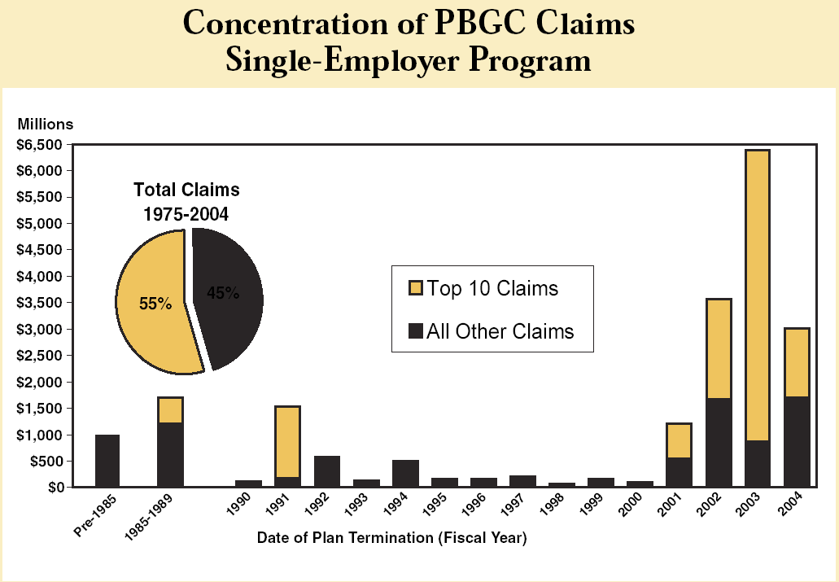
Background
Pension plans are offered by employers who pay benefits during each year of retirement as an annuity or a one-time lump sum. There are two types of pension plans: defined benefit (DB) and defined contribution (DC). A DB plan specifies the amount paid out each year using a formula that includes years of service, final year salary (or an average of the final three years salary), retirement age, and a fixed percentage rate. In order to offer a fixed amount to their employers upon retirement, firms pool the pension assets in an aggregate trust fund. A DC plan provides each employee with an individual account such as a 401 (k) or Individual Retirement Account (IRA). These accounts are funded by the employer and employee. The employee pays a fixed annual contribution determined by a percentage of their salary, which is then matched by the employer. Then upon retirement, the retiree receives benefits from the account.
Employers must evaluate the advantages and disadvantages of DB and DC plans to determine what is best for them. Companies who offer DC plans are able to remove investment risk because the employee is responsible for managing their individual account eliminating employer liability. If pension asset investment performance falls below expectations, it is the DC benefit payout that will absorb that loss. Firms also eliminate longevity risk because the DC plan is a one-time lump sum distributed upon retirement. The only real downside in offering a DC plan is increased worker turnover resulting in increased transaction costs.
There are several advantageous and disadvantageous features of DC plans for employees as well. Under DC plans, employees can move from company to company and have their plan carry over with them. Second, in a DB plan you have no say over any decisions about your investment, whereas in a DC plan, employees manage their own portfolio and receive benefits based on individual contributions and the portfolio’s performance. However, there are downsides to these DC plans for employees. DC plans offer benefits based on workers average pay throughout their careers, whereas DB plans use the salary of their final year of service or average the final three years where theoretically, earning potential is highest. Under DC plans, employees who work until retirement age and with the same company throughout their career will not be rewarded in the way an employee under a DB plan would be. There is also a shift in risk from the employer to the employee as DC plans are implemented. Employees are now faced with difficult pension investment decisions when managing their retirement account. This risk is magnified when their investment decisions result in below expected returns leaving them to absorb this loss.
In DB plans, the employer makes the saving decisions allowing them to decide what contributions are made to the plan and what investments they will use to fund the plan. Because employees are rewarded for longevity with a company, these plans encourage employee retention. This allows firms in certain industries where excessive training is required to use DB plans to reduce worker turnover thereby reducing transaction costs. Furthermore, DB plans allow the employer to obtain economies of scale when investing a single pool of pension assets through a trust. By doing this, they are able to spread their transaction costs over one pool of capital allowing for a higher net rate of return than can be obtained in an individual DC plan. However, there are also many downsides in offering DB plans. There are three significant risks that the employer must assume: investment, longevity, and funding. The employer bears the investment risk as long-term plan expense is difficult to assess. Because the employer has been promised a specified retirement benefit, they must provide additional funding to these plan’s accounts if their assets earn below expected returns. The volatility from year to year in the DB plans significantly affects a company’s business operations. Second, is longevity risk defined as, “The danger that a retiree will outlive her retirement resources (Zelinsky, 2004).” The lengthening life span of many Americans is forcing retirees to draw pension checks for longer periods of time than ever before. This, coupled with the baby boomers reaching retirement age, has created large expenses for companies paying out defined benefit plans. Finally, there is a funding risk because these pension funds rely heavily on investment growth in stocks and bonds. This has been a major problem for companies with DB plans over the past five years resulting in lackluster pension fund returns.
. For every advantage and disadvantage of DB plans from the employer’s perspective, there is a flip side of the coin. Just as there are very few downsides for employers in offering DC plans, there are few downsides for employees who receive DB plans. The only real negatives are the stiff penalties levied for job transfer and retirement before age 65. There are however, several advantageous features. First, employees are promised, in advance, a specific benefit upon retirement. Second, DB plans can offer benefits to the spouse equal to 50% of the benefits the retiree would have received. In order for an employee to receive spousal benefits, they would have to indicate this choice early on. Since, this type of annuity accounts for the life expectancies of both persons, the worker’s monthly benefit will be lower than if the employee had declined the spousal benefit. Additionally, DB plans reward loyal employees because the formula used to calculate the monthly payout incorporates longevity with a company. Finally, and perhaps most important, DB plans are insured by the Pension Benefit Guaranty Corporation (PBGC). The PBGC was established in 1974 under the congressional creation of the Employee Retirement Income Security Act (ERISA). ERISA, which set strict requirements for private pension plans, was established in response to the 1963 Studebaker collapse in South Bend,, Indiana. The collapse of Studebaker, one of the nation’s last independent automakers, left 5,000 workers without jobs and retirement pensions creating a panic among millions of American employees. The PBGC protects the pension plans of 44.1 million Americans in 31,000 private sector defined benefit pension plans. They collect premiums from employers who sponsor defined benefit plans. Table 1 lays out the advantages and disadvantages of DB and DC plans from both the employee and employer’s perspective.
Table 1
Employee
 | Advantages | Disadvantages
Defined Benefit Plans | - Promised a specific benefit upon retirement  - Know benefits they will receive in advance  - Insurance backing of PBGC  - Risk is borne by employer  - Possible annuity payments to spouse  - Rewards longevity  - Rewards working until retirement age  - Uses final year salary in benefit calculation | - Plan does not roll over if you change jobs  - Employee incurs a stiff penalty for early retirement  - Account is managed by employer
Defined Contribution Plans | - Plan rolls over from job to job  - Manage your own account | - No backing from PBGC  - No reward for longevity  - Uses average career salary  - Employees also contribute to the plan
Employer
 | Advantages | Disadvantages
Defined Benefit Plans | - Insurance backing of PBGC  - Employers manage the account  - Encourages employee retention (reduces transaction costs)  - Little government regulation  - Ability to freeze or terminate plans | - Risk borne by employer  - High costs to maintain  - Market uncertainty  - Baby boomers reaching retirement age  - Rising short-term interest rates
Defined Contribution Plans | - Lower costs  - Employers contribute equally to the plan  - Elimination of investment risk | - No insurance backing from PBGC  - Does not encourage employee retention

Current State of Under-Funded Pension Plans
Many companies have begun to freeze or terminate their defined benefit pension plans because they have become so costly over the years. As recently as five years ago, many companies had surpluses in these accounts but many have now lost millions, largely a result of recent stock market losses. The PBGC states that private pension funds were only under funded by $39 million five years ago with some companies even running a surplus. That number has now increased to $450 billion. This enormous level of under funding creates substantial risk for premium payers, the PBGC, and if nothing is done in the near future, taxpayers in the form of a bailout.

Termination of Defined Benefit Plans
Companies may terminate their DB plans in two ways. Under the standard termination option, companies choose to discontinue their DB plan, but may do so only if there is enough money to pay out their current pension benefits on the day of the termination. The company will purchase an annuity from an insurance company in order to pay the employee their benefits upon retirement. A second method of termination is known as distress termination where companies who have filed for bankruptcy are allowed to apply to the PBGC to take over their DB plans. That was the method used by United Airlines where they were able to successfully prove to a judge that it would be impossible for them to stay in business unless they could be relieved of their pension plan financial responsibilities. Under the distress termination method, the PBGC is now responsible for paying out the company’s defined benefit plans up to a maximum of $45,614 a year for workers who retired at or after 65 or a much lower amount for workers who retired before the age of 65.
By successfully terminating their current DB plans, United shifted their pension plan financial responsibility to the PBGC. The PBGC will cover $6.6 billion of United’s under funded amount in exchange for a $1.5 billion dollar stake in the company. However, the current plans are under funded by $9.8 billion and only $6.6 billion will be covered by the PBGC, leaving employees and retirees to absorb the loss. This shift will relieve United of obligations of $4.5 billion due over the course of the next five years and will certainly help them in their quest to not only exit bankruptcy, but to be a profitable company in the future.
Hardest hit financially by the United bailout will be its pilots. As of 2005, the maximum payout by the PBGC was $45,614 per year, which is far less than the annual pension in excess of $100,000 many pilots had been counting on. However, there is an even greater setback for United pilots because of stiff retirement age penalties set forth by the PBGC. Pilots are left in a vicious circle because they are required by Federal Aviation Law to retire at age 60. Because they cannot work until the required retirement age set forth by the PBGC, the new maximum payout for these pilots would be $29,650 (the maximum payout for a 60 year old retiree), nearly $16,000 less per year than they had originally anticipated under the PBGC plan. Table 2 below lists the maximum monthly payout from the PBGC corresponding to the employees’ retirement age.
Table 2 (From PBGC.gov website)
Age | 2005 Straight-Life Annuity
65 | $3,801.14
64 | $3,535.06
63 | $3,268.98
62 | $3,002.90
61 | $2,736.82
60 | $2,470.74
59 | $2,318.70
58 | $2,166.65
57 | $2,014.60
56 | $1,862.56
55 | $1,710.51
54 | $1,634.49
53 | $1,558.47
52 | $1,482.44
51 | $1,406.42
50 | $1,330.40
49 | $1,254.38
48 | $1,178.35
47 | $1,102.33
46 | $1,026.31
45 | $950.29

Freezing Pension Plans
Many companies may also elect to freeze their plans. In this scenario, they keep the plan in place, but they halt future benefits that would have been earned, drastically reducing the amount of money that they will receive. An example of a 48 year old worker who earns $45,000 a year and has been with the same company for 20 years receives a pension based on his salary upon retirement with a pension accrual rate of 1% per year. Assuming an annual raise of 4% and a retirement age of 62 at a salary of $77,925, this person would receive $26,495 per year, but if his pension plan was frozen when he was 48 years old, he would only receive $9,000 per year. An additional penalty will be incurred, because this $9,000 in nominal terms that will be received at age 65 will erode to much less in economic terms because there are no requirements for DB plans to adjust benefits to reflect inflation from the time the plan is frozen. This inflation problem would not be as serious for a plan that ended when the person was 65 years of age because there would not be a 17 year gap between the final year salary used to calculate the benefit payout.
Verizon recently froze their traditional pension plans for 50,000 managers in order to improve their competitiveness in the telecommunications market, stating their pension cuts would save them $3 billion over the next 10 years. Under this plan, employees will receive benefits they have earned up to this point, but they will not accrue any additional benefits in the years to come. Under this scenario, a 40 year old employee who has worked at Verizon for 20 years can work for another 25 years until the retirement age of 65, but they will only receive the pension benefit of a 20 year employee, amounting to hundreds of thousands of dollars in losses over the course of their retirement years.
Moral Hazard Problem
As companies freeze or terminate their pension plans, in many cases they simply transfer the financial responsibility of the plan to the Pension Benefit Guaranty Corporation. The ability for private companies to transfer all financial responsibility instantaneously creates a moral hazard problem because they pay insurance premiums to the PBGC to assure themselves the backing of this federally controlled corporation in case they become unable to pay out their pensions. This creates little to no incentive for companies to properly fund their plans under the current state of minimal government regulation. Figure 2 shows this increasing incentive for companies to under fund because they know they can transfer their defined benefit plans responsibility to the PBGC. Figure 2 shows the PBGC per year payouts to retirees since 1980.

Figure 2 (From PBGC.gov website)
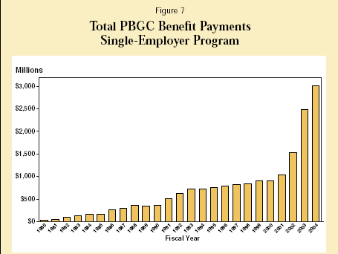
Bradley Belt, executive director of the PBGC, testified before Congress about his increasing concerns of companies relieving themselves of their pension plan financial responsibilities. “I am particularly concerned with the temptation, and indeed, growing tendency, to use the pension insurance fund as a means to obtain an interest-free and risk-free loan to enable companies to restructure. Unfortunately, the current calculation appears to be that shifting pension liabilities onto other premium payers or potentially taxpayers is the path of least resistance rather than a last resort (Belt, October 7th 2004).” Because all of these companies already pay $19 per employee to the PBGC, when they enter into a financial crisis they have no reservations about simply abandoning their pension plans because they believe they are obligated to do so because of the moral hazard created by insurance backing.
A second but similar moral hazard problem arises when companies enduring financial hardships are looking to find ways to cut costs and turn a profit. In order to retain employees, these companies will opt in favor of promising them a generous pension over the more costly method of increasing wages. This could be appealing for employees because they know they have the backing of the PBGC should their employer go bankrupt. If the company eventually recovers, they could cover the increased pension costs. However, the likely scenario is that these increased pension costs will now be transferred to the PBGC upon bankruptcy. The PBGC will then have to pass on this additional burden to other companies through increased premiums in the insurance fund. However, the current PBGC premium structure provides little incentive for proper pension funding by companies. The current flat rate premiums lead to insurance that is under priced for risky companies and over priced for companies with well-funded plans. Similar to Akerloff’s, Market for Lemons, where we begin with a higher portion of good cars to bad cars, we eventually reach a point where dishonest dealers have pushed honest dealers out of the market because people selling good cars lose money and people selling bad cars make money because we reach an average selling price in the market. Similarly, there is an eventual transfer of wealth from companies with well-funded plans to companies with under-funded plans as the healthier companies continue to lose money. Unless there becomes a premium structure whereby risky companies pay a higher price for insurance, the PBGC will only be insuring risky companies as the companies with well-funded plans are pushed out of the market. However, charging a higher premium for riskier companies will simply create an incentive for these companies to abandon their plans because there are currently no serious legal ramifications restricting against such action. As this process continues, there will become an even greater need for premium hikes as there are fewer and fewer companies paying premiums to fund the PBGC and more and more companies receiving funding from the PBGC. Eventually, we will reach a point where a taxpayer bailout will become inevitable. As long as company’s have the assurance of the PBGC as a safety net, there will always be a moral hazard problem for these companies to abandon their plans in times of financial crisis unless stricter government regulation is put into place.
Competitive Advantages Gained by Companies Who Abandon Plans
From a company’s perspective, they have determined that they might gain a competitive advantage over other firms in the industry by relieving themselves of their pension plan financial responsibilities. As many companies, especially in the airline industry, continue to abandon their pension plans and successfully get away with doing so, there becomes an incentive for other companies in the industry to follow suit in order to remain competitive. These concerns are being felt by many on Capitol Hill who believe that many airlines will follow United’s lead in hopes of a financial bailout from the U.S. government.
United’s recent bailout by the PBGC has not only saved the airline from liquidation, it has also allowed them to shed the largest expenditure over its future. The pension decision was “life or death (Tully, 2005)” for United. By allowing United to abandon its pension plan, they are now poised to make a successful return to the market. Without the huge pension burden, investors are lining up to gain a piece of the profits many foresee in the near future. The United victory will surely spur many in the industry to follow simply to remain competitive in an industry plagued with high fuel prices and new low-cost carriers. Figure 3 lists the percentage of terminations of defined benefit plans (in Dollars) by industry since 1975. The airline industry already represents the second largest burden and this percentage is sure to increase in the coming years as other airlines in the industry follow suit.
Figure 3 (From PBGC.gov website)
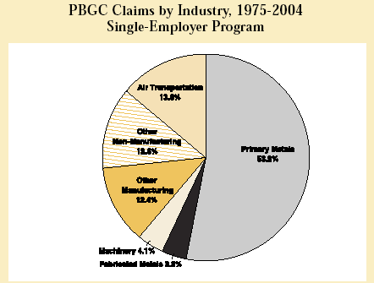
How Can Company’s Get Away with Cutting Pension Plans (Hidden Information Problem)
There is a serious hidden information problem whereby companies can legally be billions of dollars short in their pension plan funding by maneuvering around a few simple loopholes. Bethlehem Steel terminated their pension plans three years ago when they transferred $4.3 billion of their under-funded pension fund to the PBGC. In the months prior, they claimed to have had 84% of the necessary money to cover their pension plans, but the plans were actually only 45% funded when control was given to the PBGC. However, this was within the legal rules because they weren’t required to make any catch-up contributions in the years before their pension plan termination and they were even able to avoid making cash contributions for the three years prior to their plan termination. The problem was even more serious at United Airlines where their plan was under funded by $3 billion in 2000 and they were not even required to make cash contributions to their defined benefit plans from 2000-2004. U.S. House Education and the Workforce Committee Chairman John Boehner (R-OH) found that 60 of the 100 largest pension plans made no cash contributions to the pensions last year under rules that allow companies to skip payments. Their plans were technically fully funded on a current account basis, but only 41% funded when they turned over the responsibility to the PBGC. PBGC executive director Bradley Belt believes that companies’ ability to cover-up their pension plans true financial status is one of the major flaws with the current system, “Companies are able to report that they are fully funded when in fact they may be deeply in the hole and getting more deeply in the hole (De Lollis, 2005).”
Companies with DB plans are required, by law, to set aside a certain amount of assets to fulfill their benefit obligations. However, pension accounting laws allow companies to book to income the expected return on pension assets instead of the actual return. “Holding everything else constant, a company with $50 billion in pension assets and a 10 percent assumed rate of return can claim a pension profit of $5 billion, even if in reality the assets declined by 10 percent that year (Belt, March 2006).” These phantom profits have been used by many companies in recent years to increase stock prices resulting in increased executive compensation. Because companies are able to assume pension profits based on anticipated rates of return, there becomes an incentive for executives to invest in riskier assets because the rates of return increase. The incentive is magnified when pension manager performance is based on whether or not you outperform your peers in inflating portfolio assets creating an environment where all companies are putting their pension fund assets in high risk investments. Not only do current laws permit companies to disguise their pension fund’s financial status, they also allow companies to avoid making contributions to these funds when they are in fact severely under funded. Companies do not have to make annual contributions as long as a plan is funded at 90 percent of current liability, even though this number has no relationship to the amount of money actually needed to fund the benefit plan.
What Can Be Done?
The PBGC today faces a $23 billion deficit because of all of the recent pension plan terminations. Because of the PBGC’s increasing debt, the Bush Administration wants to be sure that there is no bailout of the PBGC. If the current situation continues and no reforms are made, many analysts believe that a savings and loan’s type of bailout similar to the one in the 1980’s might just be inevitable. In this bailout, the Federal Savings and Loan’s Insurance Corporation stepped in to help S&L’s as they were forced into bankruptcy due to skyrocketing interest rates, fraud, and lenient oversight. The government eventually paid $223 billion to bailout the industry. The PBGC currently has enough assets to cover their obligations for 14 more years, but they are currently paying $2 billion more per year in claims than they are receiving in premiums. Figure 4 shows the deficit and surplus fluctuation of the PBGC since 1980.

Figure 4 (From PBGC.gov website)
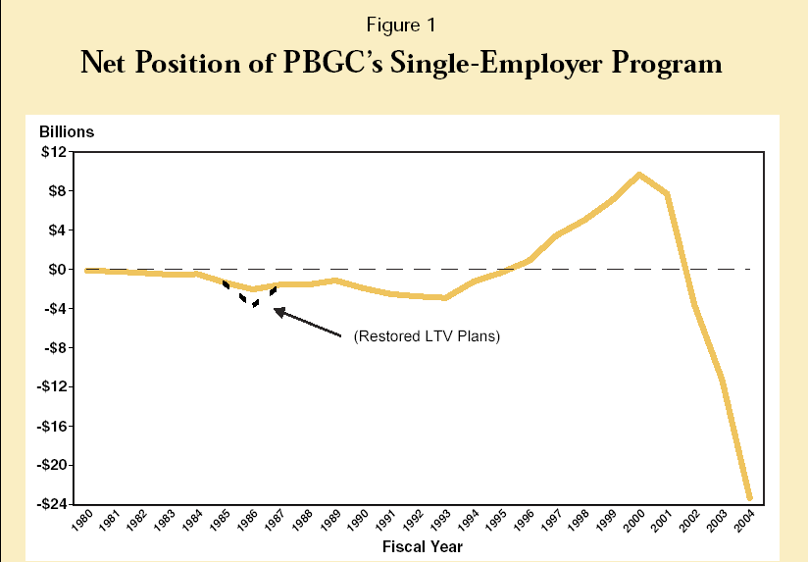
The Bush Administration has proposed a pension reform bill that introduces several key issues that must be addressed to help curtail the current pension plan problems. The first key issue is that companies can simply average the market value of their assets and liabilities over a time period when they calculate how well funded their pension plan actually is. However, this allows companies to virtually ignore the ups and downs of the current stock prices and interest rates. By reducing this time period to ninety days, the Bush Administration hopes to force companies to determine realistically how well-funded their pension plans might or might not be. Second, the pension reform bill seeks to tighten pension plan funding requirements. Currently, companies only need to fund up to 90% of their liabilities and are even given a grace period to make up these deficits. However, the bill seeks to raise this funding to 100% annually as well as raise the upper limit on what companies can contribute annually from 100% to 130%. The upper limit was initially set to prevent companies from using extra contributions as an opportunity to avoid some corporate tax, but it has only hindered companies’ abilities to add to the funds during the times of surplus. Next, companies must disclose the plans value to allow its employees to invest elsewhere if they know their company’s pension plan is severely under funded. Currently, companies only need to disclose their plans to the PBGC and not to the people that would be directly affected. Finally, the bill seeks to raise the annual premiums paid per worker to the PBGC from $19 currently to $30 to reflect the growth of wages over the past 15 years when the premium was set at $19 in 1991.
Alternatives (DC Plans: 401(k))
Many companies who terminate or freeze their defined benefit pension plans do so in favor of switching the plans over to defined contribution plans such as 401 (k)’s. While three-quarters of S&P 500 companies sponsor DB plans, there has been a significant shift away from DB plans in the past twenty years as small and medium-sized businesses have led the charge. During this time, the number of DB plans has decreased by 75% to only 31,000 plans representing only 20 percent of the workforce. However, as firms make the switch to DC plans, older employees are significantly affected. Not only do they lose their DB plans which reward longevity, they are forced to manage their own investment accounts and are almost forced to invest conservatively because they do not have the time to select riskier higher return assets. This trend has been further intensified by economic movement from the manufacturing industry toward the service sector. Companies in the manufacturing industry require employees to have company-specific skill and therefore offer DB plans to encourage employee longevity with the company. But with this continuing shift in recent years, employees in the service sector have skills that are more transferable from company to company, making DC plans more common.
Pension Wars to Come
The pension wars will be fought between companies and their employees as well as in Congress in the years to come. The recent New York City Transit strike provides one example of the increasing lack of faith that employees have in the current pension funds. The transit authority and its workers couldn’t agree on how much new employees would contribute to pension funds as the workers only wanted to pay 2% of wages for fear that their pension fund money would be gone by retirement age, while the transit authority wanted new workers to contribute 6% of wages because they need money now to pay retirees the money they are due. These types of battles will be headlining newspapers for months to come as they are fought in Congress, business offices, and courtrooms nationwide.
Conclusions
No one can dispute the statistics that more and more companies are moving away from DB plans. Companies are enduring increasing accounting costs and decreasing investments returns in recent years forcing them away from costly DB plans. While a shift to DC plans doesn’t appear to be problematic for younger generations who have ample time to invest accordingly, persons nearing retirement, particularly the baby boomers, will be significantly affected as they will not be rewarded for their lifetime company commitment and longevity resulting in thousands of dollars in losses throughout their retirement years. While job turnover seems to be the wave of the future as more and more employees obtain the necessary skills to move more fluidly from company to company, so do compatible DC plans. But the time between this shift will be financial difficult for millions of employees.

References

Adams, Marilyn. “Flight attendants to appeal pension bailout at United.” USA Today;
5/19/2005, pg 7b.

Adams, Marilyn. “Fundamentally broken pension system in crying need of a fix.”
USA Today; 11/15/2005, pg 1b.

Adams, Marilyn. “With Pensions’ Status Uncertain, United Workers, retirees afraid.”
USA Today; 6/22/2005, pg 1b.

Armour, Stephanie and Kathy Chu. “Pension problems loom for boomers.” USA Today;
12/28/2005, pg 1b.

Armour, Stephanie, Marilyn Adams and Kathy Chu. “Even healthy firms freeze or cut
loose traditional pensions.” USA Today; 12/07/2005, pg 1b.

Belt, Bradley. “Testimony of Bradley Belt before the Committee on Commerce, Science,
and Transportation in the United States Senate.” PBGC.gov website. October
7th, 2004. pgs 1-9.

Belt, Bradley. “Remarks of Bradley Belt to the US Chamber of Commerce.”
PBGC.gov website. October 8th, 2004. pgs 1-5.

Belt, Bradley. Remarks of Bradley Belt before the National Association for Business
Economics. “Through the Looking Glass: Adventures in Pension Land.” PBGC.gov website. March 13th, 2006. pgs 1-5.

Besley, Timothy & Andrea Prat. “Credible Pensions.” Fiscal Studies. March 2005,
Vol. 1, pgs 119-135.

Block, Sandra. “You can check your pension’s health.” USA Today; 7/22/2005, pg 3b.

Block, Sandra. “What workers can do to protect themselves in the age of pension
Freezes.” USA Today; 12/13/2005, pg 3b.

Borrus, Amy & Nanette Byrnes. “Rising tension over pensions.” Business Week;
5/16/2005, Issue 3933, pgs 68-71.

Business Week. “The Pension Mess: How Washington Can Start Cleaning Up?”
Business Week; 6/20/2005, Issue 3938, pg 170.

Byrnes, Nanette. “The Rush to Shut Down Pensions.” Business Week Online.
1/9/2006. pg 1.

Colvin, Geoffrey. “Tick, Tick…Boom!” Fortune; 1/23/2006, Vol. 153, Issue 1, pg 54.

Coronado, Julia and Gary Hewitt. “Is there a future for Defined Benefit Pensions in the
United States?” Benefits Quarterly. 2005 4th Quarter. Vol. 21, issue 4, pgs 41-47.

De Lollis, Barbara. “Airlines warn of pension problems.” USA Today; 6/08/2005, pg 1b.

Doyle, John. “Ready for Reform.” Aviation Week & Space Technology; 5/16/2005,
Vol. 162, Issue 20, pg 30.

Heil, Emily. “Boehner: Companies Must Do Better Job Funding Pensions.” Congress
Daily; 6/1/2005, pgs 4-5.

Jefferson, Regina. “Defined Benefit Plan Funding: How Much is too Much?” Case
Western Law Review. Vol. 44, Issue 1.

Kosterlitz, Julie. “Proposals in Congress.” National Journal; 9/03/2005, Vol. 37, Issue
36, pg 2656.

Ott, James. “United No More.” Aviation Week & Space Technology; 5/16/2005, Vol.
162, Issue 20, pgs 28-30.

PBGC website. www.pbgc.gov

Pension Benefit Guaranty Publication. “A Predictable Secure Pension for Life: Defined
Benefit Pensions.” PBGC Publication 1007. January 2000. pgs 1-20.

Shuey, Kim & Angela O’Rand. “New Risks for Workers: Pensions, Labor Markets, and
Gender.” Annual Review of Sociology. 2004, Vol. 30, Issue 1, pgs 453-477.

Tully, Shawn. “Terminal Illness.” Fortune. May 30th, 2005.

USA Today. “Risks rise for taxpayers, retires as employers bail.” USA Today;
5/20/2005, pg 19a.

Zelinsky, Edward. “The Defined Contribution Paradigm.” Yale Law Journal. December
2004, vol. 114, Number 3, pgs 451-534.

Adams, 2005.
Armour and Chu, 2005
Coronado and Hewitt, 2005
Which has advantages and disadvantages of its own.
Shuey and O’Rand 2004
Shuey and O’Rand, 2004
Zelinsky, 2004
Coronado and Hewitt, 2005
Shuey and O’Rand, 2004
Jefferson, Vol. 44
Armour, Adams, and Chu, 2005
Block, 2005
Ott, 2005
Adams, 2005
Block, 2005
Zelinsky 2004
Armour, Adams, and Chu, 2005
Belt, March 2006
Doyle, 2005
Tully, 2005
Business Week, 2005
Heil, 2005
Belt, October 7th 2004
Borrus, 2005
Kosterlitz, 2005
Jefferson, Vol. 44
Coronado and Hewitt, 2005
Colvin, 2006

