
Comparison of Institutions and Mechanisms present on eBay and the IPO marker and the Impact on Pricing

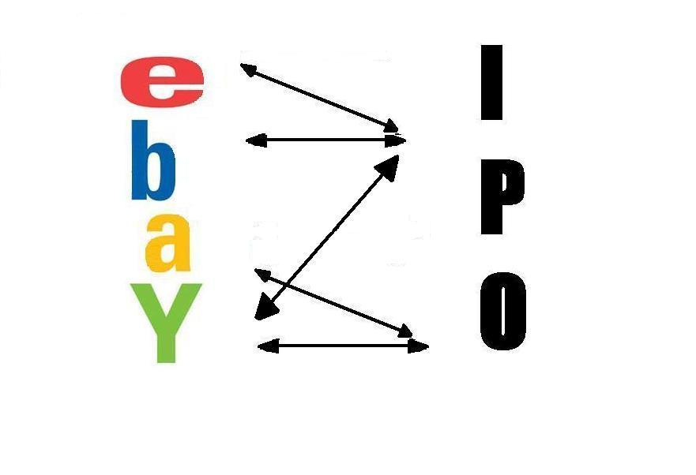

Adam Senkyrik
University of Puget Sound
May 2006

Table of Contents
- Abstract 3
- Introduction 4
- Examples of eBay Fraud 7
- Risk and Reward 8
- History 9
- IPO Investor Protection 11
- eBay Buyer Protection 15
- eBay and IPO Mechanoism and Institution Comparison 19
VIII.I Registration 19
VIII.II Third Party Information 20
VIII.III Validation of Accuracy 21
VIII.IV Governing Institution Approval 22
- Conclusion 25
- References 26

I. Abstract
eBay is a relatively new mechanism for connecting buyers and sellers from all over the world. Since most buyers never see the good till it is delivered there is a lot of inherent information asymmetry about the seller as well as the good. This has resulted in the development of institutions and mechanisms on eBay in order to eliminate the information asymmetry. The IPO market is a relatively old one that has had time to fully develop its mechanisms and institutions that eliminate information asymmetry. This is a comparison between the mechanisms that the two markets have in place and their functions and results. Based on the institutions and mechanisms a model for pricing of goods will be developed.

II. Introduction
eBay is one of the fastest growing e-commerce companies in the United States and is spreading around the world (Regan, 2001). On an average day, there are millions of items listed on eBay by sellers from all over the world (eBay, 2006). In 2005 eBay had 147 million registered users and averaged sales of over $1,300 per second accounting for over $112 million dollars in transactions each day (Donoghue, 2005). As is the case with most markets there is an asymmetry of information that allows sellers to take advantage of buyers. Like most markets over time, buyers as well as sellers on eBay developed various scams in order to rip off buyers. These scams always took advantage of the information asymmetry between the two parties. The sellers took advantage of the buyer not knowing who they were and just kept the buyers money and never delivered the good. Sellers were also known to provide false descriptions of goods in order to sell goods of inferior quality at the price of a higher quality good. As these problems arise eBay has developed numerous mechanisms as well as institutions to help eliminate some of the information asymmetry that allowed for scams. The stock market has been around for a long period of time and has to deal with its own scams. As on eBay the scams that the stock market dealt with often arose in the Initial Public Offering (IPO) market and took advantage of the information asymmetry. The IPO market is where firms first offer their stock to the public. Initially almost any company could list on the IPO market. This resulted in many failing companies going to the IPO market in order to generate money and buyers often not having accurate information about the health and outlook of the company. Due to the asymmetry of information, buyers had no way of gauging the health of the company. Over time the IPO market with the help of the Securities Exchange Commission developed a set of institutions and mechanisms to help eliminate some of the information asymmetry. The institutions and mechanisms that eBay and the IPO market have put into place eliminate some of the information asymmetry.
The price that a buyer on eBay is willing to pay for an item is not based on the market value or the utility, but is determined using the same mechanisms and institutions that determine the price of an Initial Public Offering (IPO). The occurrence of buyers not willing to pay the market value of the good exists due to the asymmetry of information between the buyer and the seller due to their conflicting interests. The reason for the similar valuation of goods in the two markets can be attributed to the similar mechanisms that both institutions employ. With the use of the two models, a pricing model for goods being sold on eBay can be constructed. The mechanisms and institutions on eBay will be compared to those in the IPO market. The comparison is useful because eBay is relatively new while the IPO market is relatively old and has had time to develop measures to eliminate information asymmetry.
The reason behind buyers not be willing to pay the market value of a good lies in the difference of interests. On eBay the seller’s main interest is to maximize the amount that their good sells for. Due to the fact that eBay connects sellers with buyers from all over the United States, as well as the rest of the world, the buyer has to depend on the description of the item that the seller provides. This dependence on sellers to provide the only description of the item, combined with their interests, creates the problem of asymmetric information. In general items that are in better condition will be valued higher than the same items that are in poor condition. Sellers with items that are in poor condition will have the incentive to provide descriptions that are not completely accurate in order to maximize the final selling price. On the other side are the buyers who are aware that the sellers might not be providing accurate descriptions. It is thus in the interest of the buyer to have as much security in the accuracy of the description for the item they want to purchase. This idea of buyers wanting accurate item descriptions and the sellers having an incentive to not provide jaccurate descriptions is what creates the asymmetry of information and buyers not willing to pay the full value of the item.
At first glance the problem arising on eBay seems like the information economics problem that is explained in “The Market for ‘Lemons’: Quality Uncertainty and the market mechanisms” (Akerlof, 1970). But this is not the case due to several mechanisms that eBay as well as the IPO market have put in place to help shrink the information gap between buyers and sellers. The shrinking of the information gap provides information about the seller as well as their past transactions providing buyers with some past information about the seller and their goods. The presence of past information is something that is not present in Akerlof’s paper making eBay’s situation a different problem. In the IPO market as well as on eBay, there are institutions in place to protect buyers from the conflicting interests of sellers. These institutions provide information about individual sellers as opposed to Akerlof’s model where buyers only knew the distribution of “lemons” for the whole market.
III. Example of eBay fraud
A recent fraud on eBay that took advantage of information asymmetry originated in Utah and resulted in the theft of over $1 million dollars for Russell Smith (Sullivan, 2003). Sullivan sold thousands of items on eBay that consisted mainly of laptops. Most laptops sold for over a thousand dollars but only a few buyers would ever receive their laptop. The customers that never received their goods were contacted and offered $50 and $100 rebates. In order to receive the rebate that buyers had to leave positive feedback on eBay. This positive feedback was misleading to other buyers and gave them a false sense of security. Once a few complaints were made to eBay after the laptops were not delivered for a few weeks an investigation was launched. The investigation was conducted with the cooperation of the Salt Lake City Police Department, Utah’s Cyber Crimes Taskforce, and the FBI. Their investigation resulted in over $1 million from over one thousand laptops that were sold on eBay, but never delivered.
There are also many other fraudulent activities that can take place on eBay due to the asymmetry of information.
Table1.
Misrepresentation: One of the oldest tricks in business. Just what it sounds like. Or more accurately, the merchandise ISN'T what it sounds like. Value, authenticity or condition may be overstated, sometimes wildly.
Failure to ship merchandise: The merchant takes your money and runs, leaving you nothing but a lighter wallet for your troubles.
Failure to pay: Through the use of fake money orders, bounced checks, stolen credit cards, or a number of other techniques, the buyer gets the goods and leaves the merchant with nothing in return.
Shilling: Artificially inflating the price on an item by use of fake bids from phony user IDs or accomplices.
Bid Shielding: Using high bids from phony accounts to run up the price and scare off potential buyers, the actual bidder then retracts the higher bids, getting the item at a much lower price than he would have otherwise.
Piracy and counterfeiting: The sale of pirated music and software or counterfeit art, phony jewelry or gems, and forged collectibles.
Internet Fencing: Selling stolen goods through the auction.
Triangulation: The seller offers to send you the item (usually new, brand name goods) on approval. They then use stolen credit cards to order the item shipped to you. You pay for the goods (in cash) after receiving them, and get a visit shortly thereafter from the police. Credit card fraud and theft.
The "Buy and Switch": The buyer gets the merchandise and returns a similar item that has been damaged, or a fake, with the claim, "It isn't what I expected." The seller refunds their money, and is left with broken and unresellable product.
Fee stacking: Fees, usually "related" to shipping costs, are added to the cost after the sale has been made.
Loss or Damage Claims: Not always fraudulent. After all, things do get broken in transit. Often these claims are a result of the buy and switch, or careless handling by the buyer.
Shell Auctions: No merchandise exists. The sole purpose of the auction is to get money or credit card numbers from unwary buyers.
IV. Risk and reward
eBay as well as the IPO market seem to be an inherently dangerous place to do business. So why would people go to eBay or the IPO market? The common reason for people to engage in activity in the IPO market and on eBay is the possibility of positive gains. The IPO market represents an investment in the form of shares of a company and the possibility of positive returns based on its performance. If the IPO performs well there are positive returns in the form of a higher stock price. As is with most investments, the greater the risk the higher the returns can be (Chung, Li, Yu, 2005).
On eBay the risk and reward comes in the form of the asymmetry of information about the item and seller and the final paying price. The information asymmetry results in risk on eBay. This is because the lack of information about the seller can result in the theft of money and no possibility of retrieving it. Also since the only source of information about the item is the seller creates even more risk. The buyer pays a price based on the amount of risk that they perceive like the Akerlof model in “The Market for Lemons.” The reward on eBay can be the buyer receiving a good that has quality above the expected quality. So the gain will be the difference between the actual higher quality of the good and the quality that was expected and paid for. Again the reason why ultimately this model ends up different that that of Akerlof is due to the presence of Institutions and mechanisms that help eliminate some of the inherent information asymmetry. The absence of some of this information asymmetry results in higher expected values of goods.
V. History
The stock market has been around for decades and as a result of it longevity has been studied and modified with regulations to ensure its survival and success. eBay on the other hand is still fairly young and minimal research has been done to identify it functions and what economic mechanisms are at work. The stock market has become a major player in the United States economy and it is the goal of many companies to have their presence on it index. In order for a company to be traded on the stock market it needs to issue an IPO. An IPO is the selling of shares in the company and essentially part ownership of that company. The finds from an IPO are usually used to sustain growth or to provide the necessary funding for an expansion. By having stocks traded on the stock market, a company and its owners can achieve great wealth in a very short period of time. This often makes them the target of scams. Most of these scams are a result of asymmetric information. This information asymmetry is often about the financial wellbeing of the company and its holdings. Over time, as people’s investments in fraudulent companies were lost, mechanisms were put into place to prevent this from occurring. Other than ensuring the safety of investors, the mechanisms that were put in place by the stock market as well as the Securities Exchange Commission (SEC), helped ensure that companies would stay around for a long time to help ensure the survival and well being of the stock market. Over time revisions in the regulations that govern the stock market, as well as the issuing of IPO’s, have made the stock market into a safe and trusted place and the market for IPO’s very lucrative.
eBay is a relatively new company that is still growing rapidly as well as evolving. The eBay that most people now know started as a small company that created a place for people to auction off small random things around the house that they did not need anymore. And in return buyers could find random junk that perhaps is not sold in stores anymore that they had been seeking. This helped develop the slogan that much of the eBay community uses, “some one’s garbage can be someone else’s treasure.” Soon other goods started to appear on eBay such as clothing, bicycles, and electronics which attracted more users. Currently on eBay, almost any goods except for drugs, certain weapons, and body parts can be found along with a wide variety of services. eBay also supports the sale of any vehicle including boats and airplanes as well as real-estate. During its early years eBay had to deal with many fraudulent actions that all revolved around an asymmetry of information. In the beginning many of these asymmetries had to do with the credibility of the seller and the buyer not knowing that they would make off with their money without ever sending the good. The sellers also had to deal with problems created by information asymmetry in the form of some buyers not sending them their payment after the auction was over or sending fraudulent payments. Also there were information problems about the advertised quality and functionality of the goods that were for sale. After all, being able to sell something to someone without them being able to inspect it attracts that kind of behavior. Slowly, some of these issues have been resolved with mechanisms that eBay has put in place.
VI. IPO investor Protection
The Securities and Exchange Commission is the body that regulates the stock market as well as the IPO’s after being appointed that power by the Securities Act of 1933. The SEC has devised a very stringent process that companies have to go trough to issue an IPO. This has been done to ensure the safety of potential investors as well as maintaining the performance and integrity of the stock market. The current process to issue an IPO for one company now involves multiple companies and takes around 16 weeks to complete. The IPO issuing process follows several steps once a company decides that it wants to go public. First the company has to find an underwriter. The underwriter is an investment banker that is employed by a large bank and underwrites the IPO. This means that the underwriter’s bank purchases the shares from the company at some price and then sells them to the public for more money in order to generate profit for both parties. Often this one bank ends up partnering up with many other banks and brokers in order to maximize the distribution. The company will then have to file a registration statement and a preliminary prospectus with the SEC. This is to inform the SEC of their intent to issue an IPO as well as outlining the final prospectus.
The registration statement is mainly used to help create symmetrical information by providing some crucial information about the company. The Registration statement contains the following information;
- A description and basic overview of the company and how the funds generated by the IPO will be used
- The company’s capitalization
- Legal proceedings that the company is involved in
- Information about the company’s officers and directors
- The amount of securities that are owned by the officers, directors, and stockholders that own more then ten percent of the company
The first part of the registration, which explains the company and its plans for the funds generated, is there to provide investors with basic information about the company and how the money will be used. The use of the funds is especially important because if they are not used to generate growth then they will most likely be used to make someone else rich and not the investor. The company’s capitalization will provide investors with information about the financial health of the company, thus helping to alleviate even more potential information asymmetry. The capitalization information is composed of private audits done by private companies to ensure accuracy and often more than one audit is performed and provided. Also the legal proceedings are an essential part of the registration since pending lawsuits with bad outcomes could be disastrous for investors. Finally, the information about the people that are in charge of the company and the people that own large portions of it is important so that investors know who is making the decisions.
Following the registration statement and the preliminary prospectus is the cooling off period. The cooling off period is time for the SEC to review the registration statement and give the brokers time to search out more potential clients. The Indications of Interest also need to be filed with the SEC. The Indications of Interest consists of investors indicating that they would be interested in purchasing the IPO from the underwriter. This is there to let the SEC know that there is actual interest in the IPO and that the underwriters have already found potential buyers for the IPO ensuring some success while getting some idea of the interest for the IPO. The investors that are mentioned in the Indications of Interest are not legally bound to purchase any of the IPO once it is offered.
The Final Prospectus is released after the Indications of Interest and contains all of the information that was in the registration statement and preliminary prospectus with the appropriate amendments made. Also information included in the final prospectus that was not in the preliminary prospectus is the offering price, underwriter spread, dealer discounts, and other financial information. The Final Prospectus includes the following information;
- Description of the offering
- History of the business
- description of management
- Price
- Date
- Selling discounts
- Use of proceeds
- Description of the underwriting
- Financial information
- Risk to potential investors
- Legal opinion regarding the formation of the company
- SEC disclaimer
The information in the final prospectus is for the most part the same but also includes an analysis of the company in its current state as well as its future outlook. This is done to help eliminate asymmetric information by providing potential investors with accurate information as well as the opinions of professionals for those investors that do not poses enough knowledge. The risks as well as a disclaimer are also added to remind investors that it is their risk that potentially can lead to returns on their investment. The SEC review ensures that the company has filled all appropriate information but does not guarantee its accuracy. The SEC does not ensure that the IPO is of high quality or that it has the potential to perform well, it leaves that function to outside independent mechanisms. Once the Final Prospectus is filed and released then the brokers can start taking orders for the IPO.
VII. eBay Buyer Protection
In attempts to eliminate the information asymmetry that exists on eBay and prevent sellers from taking advantage of buyer’s, eBay has put in place several mechanisms. One of the major mechanisms that provide security and information symmetry on eBay is the requirement for sellers to register a Pay Pal account. A Pay Pal account is an online electronic funds transfer agent that allows for the use of credit cards, linking up to a checking account, and it can also be used as a bank account. A requirement for eBay sellers that are registering with Pay Pal is to verify their bank account as well as a credit card. What this verification does is contact the seller’s bank and verify with the bank that the information that eBay and Pay Pal were provided with is accurate. This ensures that the seller exists and that there is a person that can be reached in case of fraudulent activity. Requiring verification of the account also forces the seller’s bank to make sure that the account in question has all of the required information and that no corners were cut in creating the account, such as using a false identity. PayPal is also an industry leader in fraud detection technology as well as fraud detection (eBay, 2006). Pay Pal provides both sellers and buyers with an extra layer of protection incase any asymmetry of information does arise. This is done by allowing both parties to contest a payment that was either made or received trough Pay Pal, a feature that also most credit cards provide. That coupled with the fact that most Pay Pal users use a credit card to make payments the payment in question can be contested with either Pay Pal or the credit card company. Also both eBay and Pay Pal have feedback mechanisms for both sellers and buyers that helps create more information symmetry for future users. This is accomplished by allowing the parties to leave the other with either positive, neutral, or negative feedback as well as a short statement. This feedback is saved by both eBay and Pay Pal and allows future users to analyze information about that users past, integrity, and determine if their descriptions reflect the quality of their goods.
Steps of an eBay sale;
- Item is listed on eBay by a seller
- eBay verifies that it is not a banned item
- Potential buyers make bids on the item
- Auction ends and highest bidder wins
- Winning buyer pays for the item
- Payment clears
- Seller sends the item to the buyer
- Seller leaves feedback for the buyer
- Buyer receives the item
- Buyer leaves feedback for seller
The beginning of an eBay sale is the seller listing their good on eBay and providing a description of the item. The description will often consist of a photograph as well as a written description and possibly some manufacturer specifications. Once the listing is submitted it takes a few hours until it appears on eBay. During this time, eBay verifies that it is something that can be sold on eBay based on the provided description. Once it is verified by eBay the item is posted on eBay and available for potential buyers to search for it. During this time potential buyers can make bids on the item till the auction expires at some predefined time. Once the auction expires the highest bidder is the winner of the item and is expected to pay for it. The winning bidder pays for the item and the funds make their way to the sellers PayPal account. Once in the PayPal account, the seller awaits confirmation that the buyer did have enough money and that the payment did in fact clear. Once notified of a cleared payment the seller sends the item to the buyer and leaves feedback for them. The buyer receives the item and leaves feedback about the seller using the feedback mechanism.
The feedback mechanism on eBay is what provides buyers with information about the past sales of a buyer. This feedback can only be left by people that have engaged in a transaction with that buyer. The feedback is in the form of a positive, negative, or neutral rating, as well as a short comment about the transaction and the reason for the rating given if desired. This is a resource that future buyers can use to see the manner that past transactions were conducted in. Meaning that it provides information such as if the item was delivered at all and in a timely manner, as well as if the description of the item was accurate. Most of it will also indicate if past buyer’s interests were satisfied or not.
For most sellers this process occurs multiple times as they sell more items building up what is referred to as seller reputation. Seller reputation is a combination of the amount of feedback that a seller has. Meaning how many transactions they have gone trough. Seller reputation also entails the percentage of feedback that they have received that is positive and how long the seller has been an eBay member. All of this information is always displayed in the top right hand corner of each item offered on eBay so that it is visible for all sellers. The buyer can also view all of the feedback on past items as well as the past items listing. This helps eliminate some of the information asymmetry and can help buyers gauge the risk that they can have when doing business with that seller.

VIII. eBay and IPO Mechanism and Institution Comparison
Both eBay and the IPO market have mechanisms and institutions in place to protect the interests of the buyer from the conflicting interests of the seller. These mechanisms and institutions also effect the price that buyers are willing to pay based on the information that the sellers provide. In both markets it is the same principles in parallel mechanisms and institutions that result in the same pricing effects in both markets. The mechanisms and institutions in question in the IPO market are the financial audits, underwriters for the IPO, and the SEC. On eBay the relevant parallel institutions and mechanisms are PayPal and eBay, as well as the information that is included in the seller reputation (feedback amount, feedback ratings).
VIII.I Registration
In order to eliminate some of the information asymmetry, both eBay and the IPO market have developed Institutions to provide buyers with accurate information. The SEC mandates that all businesses be registered with them. This registration provides information about the major shareholders/owners as well as the company officers. This way the consumer knows who the people that they are dealing with are and that if laws are broken it will be known who the relevant individuals are. The SEC’s parallel on eBay for this function is PayPal. PayPal’s purpose other than funds transfer is to authenticate the identity of the seller. This way if there is a problem eBay as well as the buyer will know who the person is and the buyer does not have to worry about fraudulent activity. Both have the function of providing the buyer with information about the seller thus helping to decrease some of the risk that is associated with information asymmetry.
VII.II Third Party Information
The parallel mechanisms that have one of the largest impacts on the final pricing are the underwriter of the IPO and the feedback score of the eBay seller. The prestige of an underwriter has been found to have a large impact on the final price of the IPO (Datta, Iskandar-Datta, Patel, 1997). Underwriter prestige is associated with their historical performance that is often attributed to their knowledge of the industry as well as good judgment. This means that prestigious companies will only underwrite an IPO for a company that they believe will perform well. Firms that are capable of performing well will end up with a prestigious underwriter due to their interest of maximizing their profits. This means that all firms will attempt to have a prestigious underwriter underwrite their IPO but underwriters will only select the companies that they expect to perform the best. The companies with less optimistic outlook and current standing will end up with less prestigious underwriters. The parallel to underwriter prestige on eBay is the prestige of the seller. Prestige of the seller on eBay is reflected in the feedback score that they have accrued. Feedback Score is reflected with one point for a positive feedback, no points for a neutral feedback, and a negative point for a negative feedback. This means that as a seller is involved in more successful transactions this number grows. As the number gets larger eBay also starts attaching various stars to catch a buyers attention and titles such as “Power Seller” to give buyers more confidence in that seller. It has been found that a higher feedback score results in a higher final selling prices on eBay (Livingston, 2005). Livingston found that higher feedback results in a higher selling price. He also found that the selling price increases dramatically with the first few feedback score points, and after that the marginal returns decrease but still exist.
VIII.III Validation of Accuracy
Another institution in the IPO market that has a parallel on eBay to help eliminate some of the information asymmetry are the financial auditors that are paralleled by the eBay community. The SEC requires companies that want to issue an IPO to have a financial audit that is published and can be examined by the SEC. The financial auditors verify that the published finances of the company are accurate and not fraudulent. The company’s finances are a large indicator of how well the company can perform in the future. Thus, investors base their decision to invest on the company’s financial stability. The auditors confirm that the description of the company is accurate to give investors some security in their decision. There is also a level of prestige associated with auditors, and Michael and Shaw found that;
- more prestigious auditors are associated with IPO’s that seem a priori less risky
- the market perceives as less risky the IPO’s that are associated with more prestigious auditors
- IPO’s' long-term performance is related to the prestigious of the auditor employed
This means that buyers in the IPO market trust the opinion of someone to inform them on how risky an investment is. They then base the price that they are willing to pay for the investment on that expert opinion. The parallel to this on eBay is the feedback that is left by the eBay community for the seller. The feedback reflects the accuracy of past item descriptions as well as other aspects of the transactions. In addition, it has been found that the higher the positive feedback percentage, the higher the selling price of a good (Melnik and Alm, 2005). This shows that buyers will develop some sense of trust based on the past opinions of others.
The role of auditors can also be paralleled to feedback score and the fact that more is better. While a prestigious auditor results in a higher selling price of an IPO due to the association that they are less risky (Michaely and Shaw, 1995). The effects of a prestigious auditor can also be replicated with numerous auditors (van der Goot, 2003). This parallels on eBay with higher feedback scores resulting in higher selling prices (Livingston, 2005). The function of auditors and feedback scores work parallel in this case due to the fact that they also eliminate some of the information asymmetry.
VIII.IV Governing Institution Approval
The SEC’s approval is the final step before the IPO hits the market, ensures that all the final changes are made, and that eBay has approved the item. The SEC approval consists of the SEC verifying that all of the appropriate steps to help minimize the asymmetry of information have been taken. It does not ensure that the IPO will perform well though and informs investors of the risk they are taking. When eBay approves an item for sale it is because the seller has provided all of the information that is required and has been verified by PayPal. So the eBay approval for the sale of the item is eBay acknowledging that the seller has done everything required of them to eliminate as much of the asymmetrical information as possible.
Table 2.
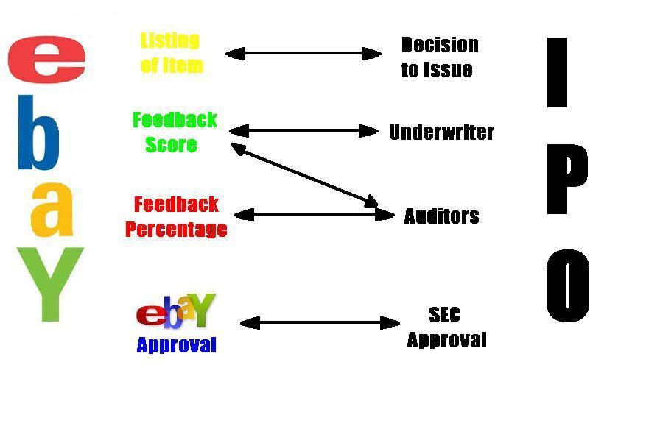
The table shows the mechanisms and institutions that function in parallel on eBay and in the IPO market.

IX. Conclusion
The IPO market and eBay have similar mechanisms and institutions that achieve the elimination of a majority of information asymmetry that is inherent in both markets. Both sets of mechanisms and institutions do this in comparable manners, using the same principles to help provide buyers with accurate information. This results in the buyers valuation of IPO’s and items on eBay and is ultimately determined using similar mechanisms and institutions as opposed to just using the market value.
The five main mechanisms and institutions that are used on eBay are eBay registration, PayPal, feedback score, feedback percentage, and eBay approvals of the listing. Ultimately only the feedback score and feedback percentage will have a non-constant impact on the valuation of the item on eBay. PayPal approval, eBay registration, and eBay approval of the listing, will have a constant effect on the price of all goods on eBay because all sellers are required to have it. But it is the feedback score and feedback percentage that differ from seller to seller. The final price of a good on eBay will BE something as follows;
$$P_{f}=P_{o}+V+E+R+f(S)+f(A)$$
$P_{f}$= the final price of the item
$P_{o}$= the price of the item in a market with no safeguards
V = Value added due to the information provided by PayPal Verification.
R = Value added due to the information provided by eBay registration.
f(S) = Function of value added due to the information that that is provided by the feedback score and will be an asymptotic function. Livingston’s research supports this with the first few points of feedback score having a significant impact on the final selling price. But as the feedback score increases the marginal returns decrease.
f(A) = Function of the value added due to the information provided due to the feedback percentage.
E = The value added due to eBay approval of the item listing
On eBay the final price of the good is impacted by the amount of information asymmetry that is eliminated.

X. References
- Akerlof (1970). “The Market for ‘Lemons’: Quality Uncertainty and the Market Mechanism.” The Quarterly Journal of Economics, Volume 84, Issue 3. 488-500
- Chung and Li and Yu (2005). ”Assets in Place, Growth Opportunities, and IPO Returns.” Management v34, n3 (Autumn 2005): 65-88
- Datta and Iskandar-Datta and Patel (1997). “The Pricing of Initial Public Offers of Corporate Straight Debt.” Journal of Finance v52, n1 (March 1997): 379-96
- Donoghue, Andrew (2005). “eBay: let’s wait and see on tighter security.” cNetNews.com. Available: http://news.com.com/eBay+Lets+wait+and+see+on+tighter+security/2100-1029_3-5695440.html
- eBay (2006). “Buyer Protection.” eBay.com
Available: http://pages.ebay.com/paypal/buyer/protection.html
- eBay (2006). “The Company.” Overview of eBay Available: http://pages.ebay.com/aboutebay/thecompany/companyoverview.html
- eBay (2006). “Feedback Forum.” Available: http://pages.ebay.com/services/forum/feedback.html
- eBay (2006). “PayPal Verification.” Available: http://pages.ebay.com/paypal/buyer/verify/
- eBay (2006). “Trust and Safety.” Available: http://pages.ebay.com/aboutebay/trustandsafety.html
- Lanford, Audri and Jim. (No Date). “Online Auctions: Deal or Steal?” ScamBusters.org
Available: http://www.scambusters.org/Scambusters43.html Livingston (2005). “How Valuable Is a Good Reputation? A Sample Selection Model of Internet Auctions.” Review of Economics and Statistics v87, n3 (August 2005): 453-65
- Melnik and Alm (2005). “Seller Reputation, Information Signals, and Prices for Heterogeneous Coins on eBay.” Southern Economic Journal v72, n2
- Michaely and Shaw (2005). “Does the Choice of Auditor Convey Quality in an Initial Public Offering?” Financial Management v24, n4 (Winter 1995): 15-30
- PayPal (2006). “Prevention and Protection.” PayPal.com
Available: https://www.paypal.com/cgi-bin/webscr?cmd=xpt/general/SecurityFraud-outside
- Regan (2001). “eBay Fastest-Growing Tech Firm in U.S.” E-Commerce Times Available: http://www.ecommercetimes.com/story/14776.html
- Sullivan, Bob. (2003). “Man arrested in huge eBay fraud.” MSNBC.com Available: http://msnbc.msn.com/id/3078461/
- Street Authority (2006) “Definition: Initial Public Offering.” Available: http://pages.ebay.com/paypal/buyer/verify/
- van der Goot (2003). “Risk, the Quality of Intermediaries and Legal Liability in the Netherlands IPO Market.” International Review of Law and Economics v23, n2 (June 2003): 121-40

Courtesy of Lanford @ ScamBusters.org/
http://www.streetauthority.com/terms/i/ipo.asp All IPO procedures and regulations are from here
eBay/PayPal Verification
eBay Verification
eBay Feedback forum
The eBay community consists of buyers and sellers
(Michaely and Shaw, 1995)
Feedback in the form of percentage total feedback being positive
This would be a market such as Craigs List or a classified add where there are no safeguards such as registration. There also is no overseeing body or institution and due to this large asymmetry of information there is a large amount of inherent risk. The higher the risk is the lower the prices will be. This is inline with Akerlof’s Market for Lemons and the idea that with the risk of goods of lower quality being present the overall expected quality of the good will decrease.

